Architectural Analysis

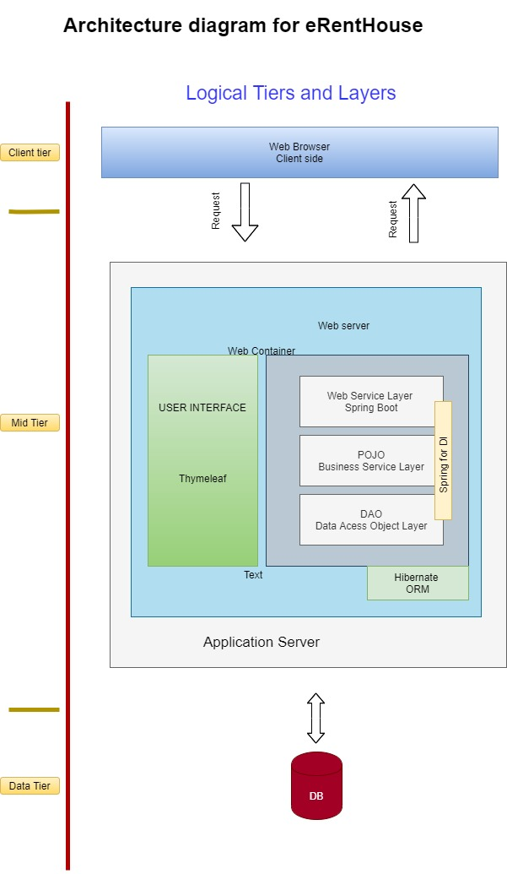

The Key Abstractions which can be identified for our project are:

1. owner

2. Customer

3. House

5. Address

6. Booking